**PRACTICAL: 01**

**AIM:**

Practical Exercises in Email Writing

**QUESTION 01:**

You were unable to complete an assignment due to illness. Write an Email to your professor requesting an extension on the submission deadline.

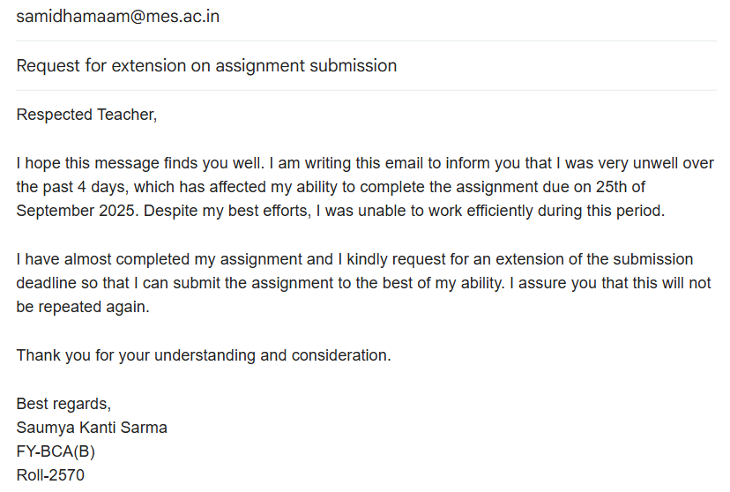

**QUESTION 02:**

Write an email accepting a job offer, confirming the joining date and expressing gratitude.

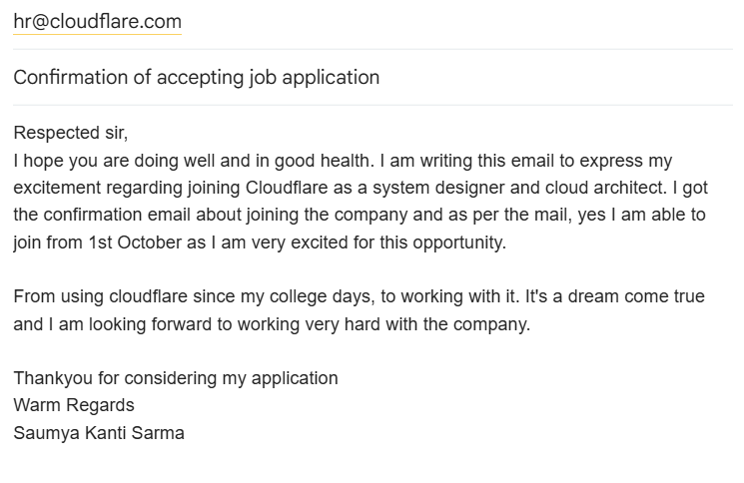

**CONCLUSION:**

Email writing performed successfully

.

**PRACTICAL 02**

**AIM -**

Learning PowerPoint:

A] Create 5 slides using Microsoft PowerPoint.

B] Create a 5 - slide Canva presentation on Recycling of plastic.

C] Prepare a 2-minute video in Canva.

D] Design Flyers / Business cards for any company.

**2 [A]:**

******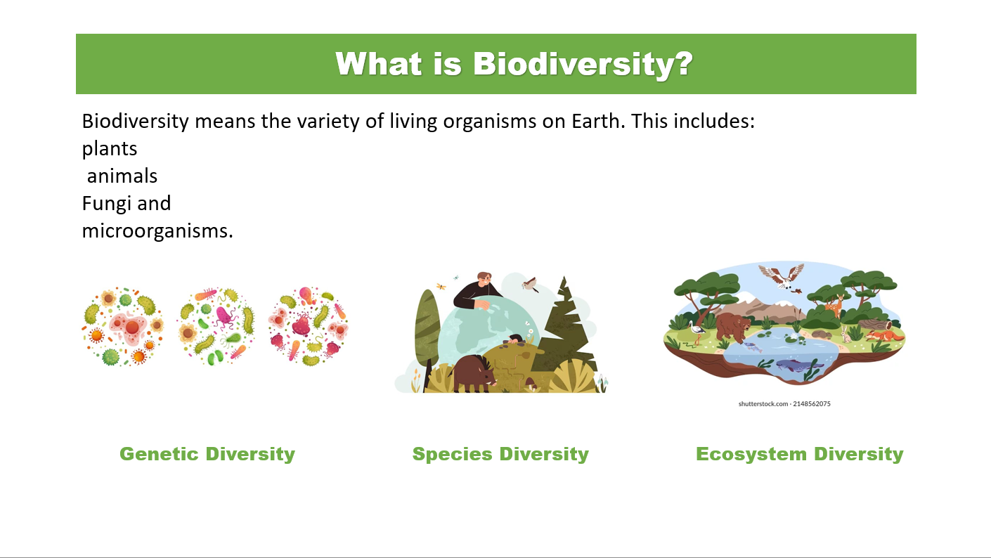

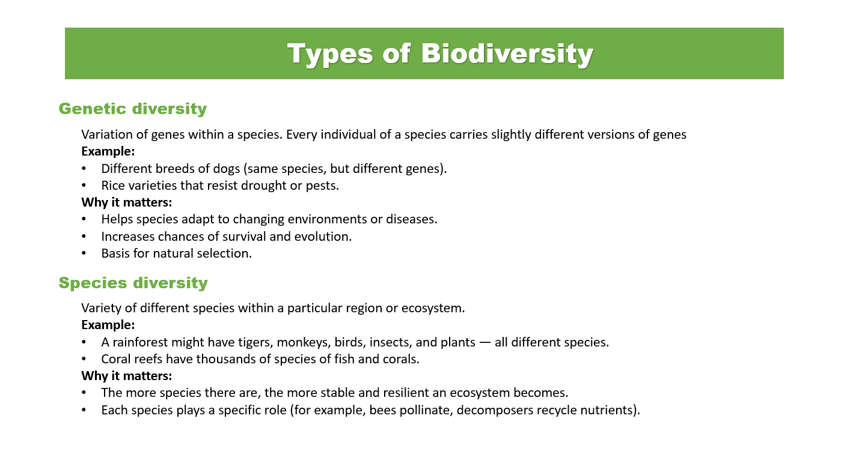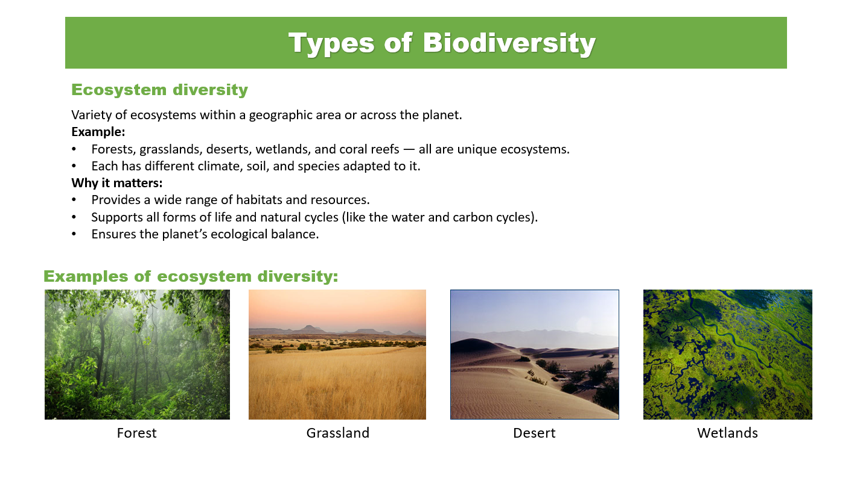

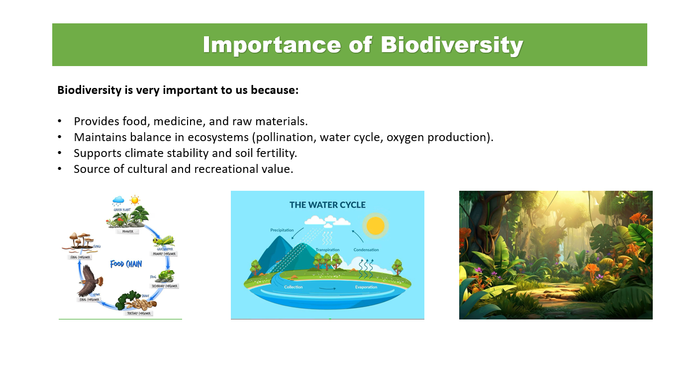

**2 [B] :**

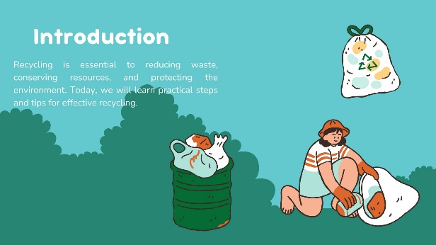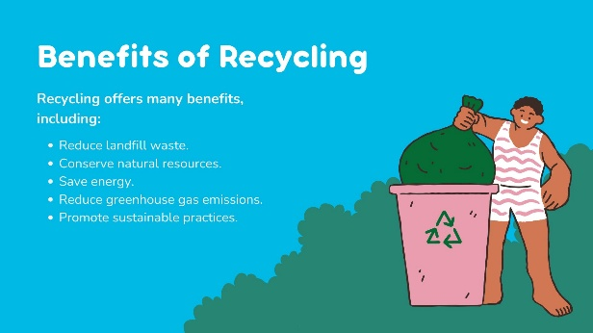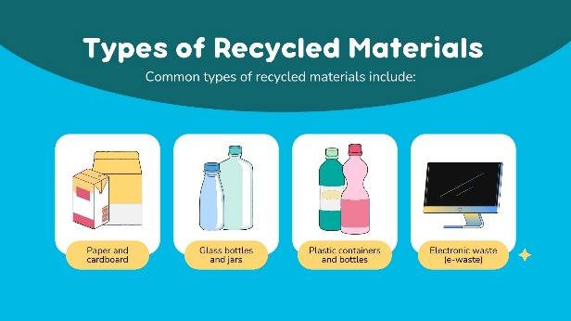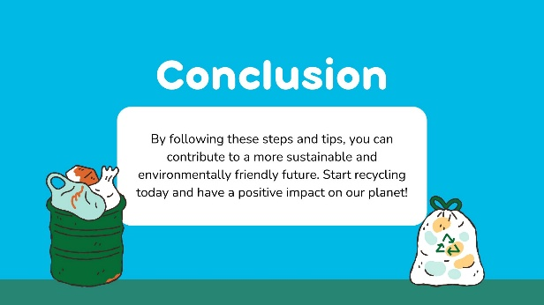

**2 [D] :**

Business card



Flyer



**CONCLUSION -**

Hence, we have successfully implemented powerpoint skills and made presentations using Microsoft and Canva applications. Additionally, we have also completed Business cards & flyers in Canva.

**PRACTICAL 03**

**AIM -**

Learning EXCEL:

A] Introduction to MS Excel files, Workbooks, Worksheets, Columns and Rows.

B] Formatting Worksheets.

**3 [A]:**

**INTRODUCTION -**

Microsoft Excel is used to organize, calculate, analyze, and visualize data in spreadsheets for a variety of purposes, including financial management, data entry and management, project tracking, budgeting, and creating charts and graphs.

**Core Functions -**

* ***Data Organization and Entry:*** Excel creates grids of cells in rows and columns to hold text, numbers, and formulas, allowing users to easily organize and input data.
* ***Calculations and Formulas:*** Users can apply formulas to perform complex mathematical operations, such as sums, averages, and other values from numerical data.
* ***Data Analysis and Visualization:*** Excel provides tools like pivot tables to summarize large datasets and charting tools to create various graphs, bar charts, and histograms to visualize trends and insights.

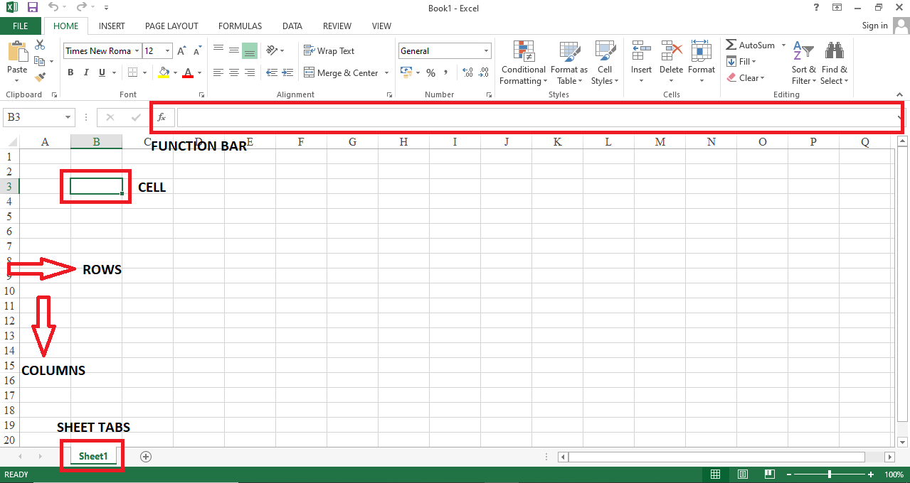

**3 [B] :**

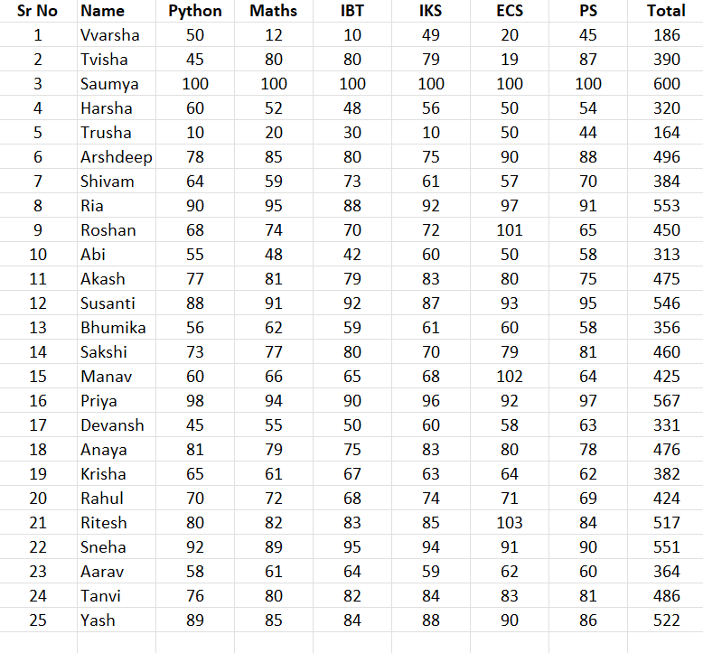

**CONCLUSION -**

Hence, we have successfully completed formatting in excel.

**PRACTICAL 04**

**AIM -**  
EXCEL :  
A] Header and Footers.  
B] Number and Decimal numeric formats.  
C] Working with Formulas (Maximum, Minimum, Average, Count and Sum).  
D] Percentage Numeric Formats.

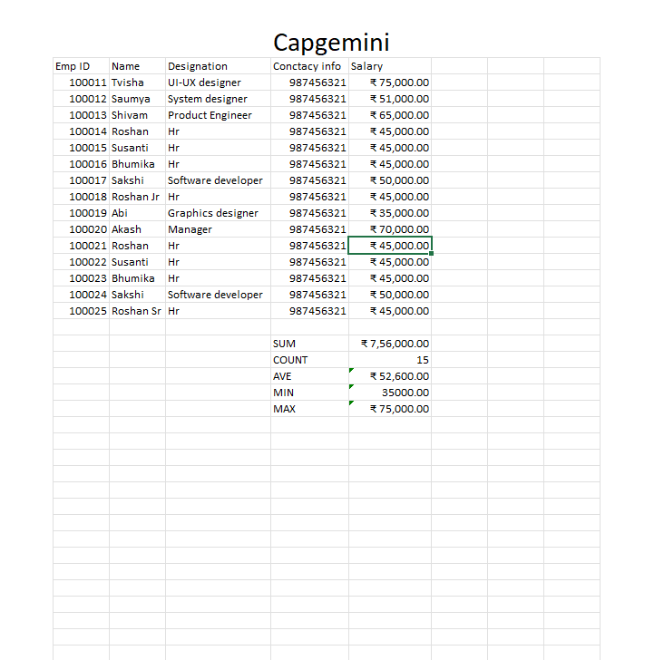**CONCLUSION -**  
Hence, we have successfully implemented the excel techniques.

**PRACTICAL 05**

**AIM -**  
Advanced Excel: Conditional Formatting, Sorting, Subtotal, Advance Filtering

**Conditional FORMATTING:**

**Task –**

1. Highlight all employees with **Salary > 55,000** in **green fill.**
2. Use **Data Bar** on the Salary column to show salary variation visually
3. Highlight employees from **Delhi** with **Light blue background.**
4. Use **Icon Sets** to show salary performance:

* Green icon for above 60,000
* Yellow for 50,000-60,00
* Red for below 50,000

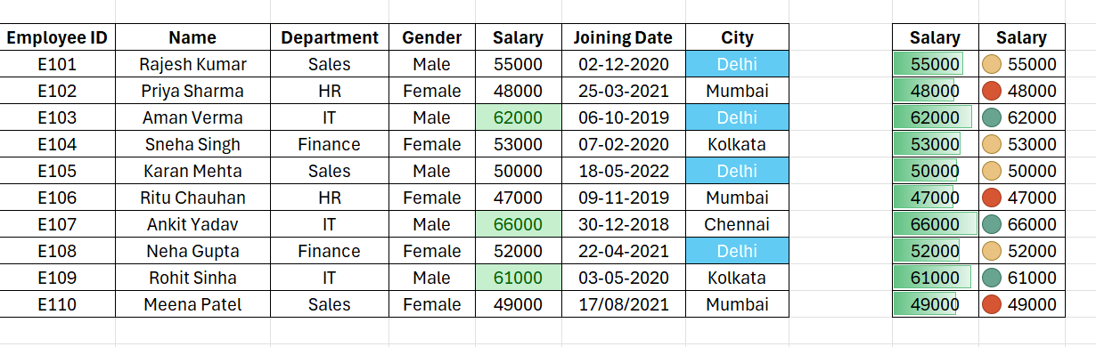

**SORTING:**

1. Sort the entire **Dataset** by **Department ( A-Z )**
2. Then, perform **multilevel sorting**

* First by **department**
* Then by **salary (Largest to Smallest)**
* Sort by **joining date (Oldest to Newest)**

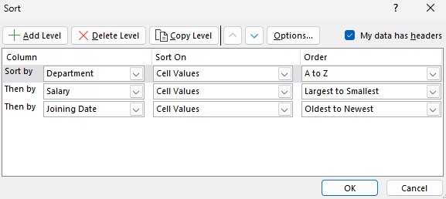

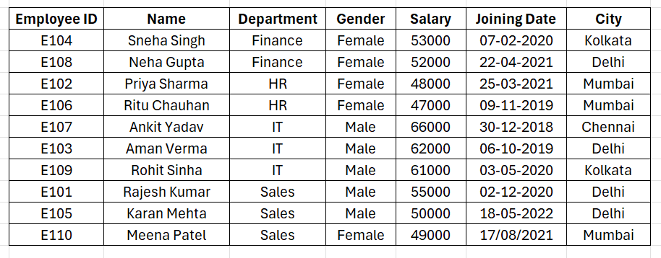

**SUB-TOTAL:**

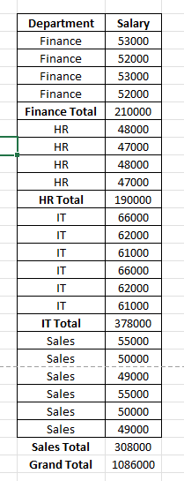 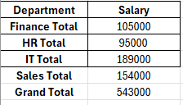

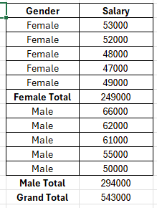 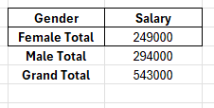

**ADVANCE-FILTRING:**

1. Create a criteria range (e.g. **City - Mumbai**)
2. Filter employees who:

* **Work in IT**, and
* Have **a Salary > 60000**

1. Copy the filtered data to another location.
2. Try a second filter

* Employees from **Delhi** OR with **Salary < 50000**

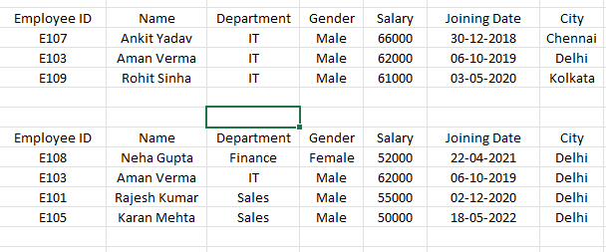

**CONCLUSION -**  
We have completed the practical implementation of advance excel techniques.